**Step 1 :** visit <https://getchef.opscode.com/signup> and self sign up

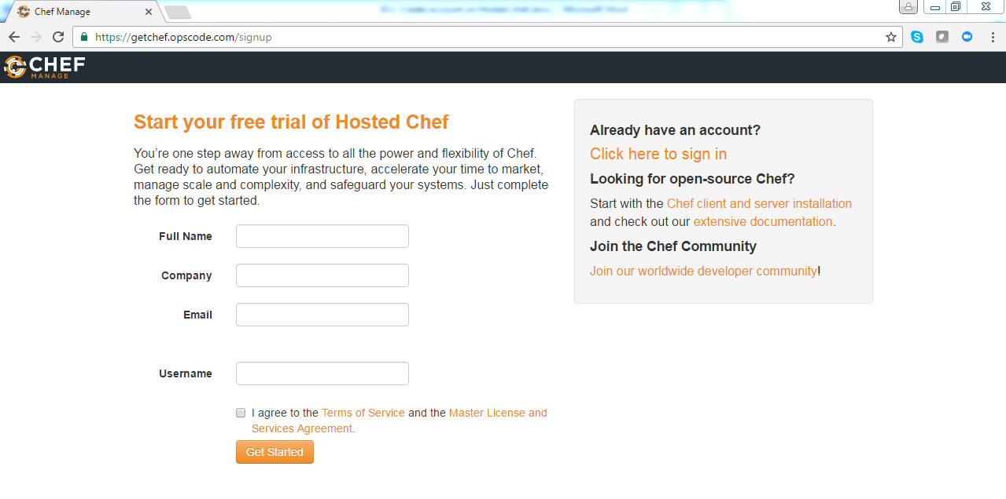

**Step 2 :** follow the Instructor screen for next steps after signup